BRICK BREAKER!!!

## Objective

Welcome to Brick Breaker!!! In this game, we try to break all the bricks on the playing field by using one ball to hit them all.  
  
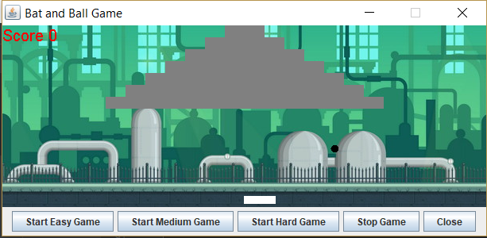  
  
Here we have the playing field which consists of a number of gray bricks, one black ball and a white bar.  
  
Controls

Move bar right – Right Arrow Key

Move bar left – Left Arrow Key